ASSIGNMENT COVER PAGE
Qualification |  | Module name and title
Higher diploma in computing and software engineering |  | CSE4002  Fundamentals in programming
Student No and name |  | Assessor
Yumna Faris  KD/HDCSE/CMU/81/18 |  | Ms. Dushyanthi Nisansala
Handout date |  | Submission date
2025.09.02 |  | 2025.09.03
Assessment type  WRIT 1 | Duration/length of assignment  3000 WORD | Weighting of assessment  100%

Learner declaration
I, Yumna Faris, certify that the work submitted for the assignment is my own and that research sources are fully acknowledged.

Marks awarded
First assessor
IV marks
Agreed grade
Signature of the assessor
Date

FEEDBACK FORM
MODULE: FUNDAMENTALS IN PROGRAMMING
ASSESSOR: MS. DUSHYANTHI NISANSALA
ASSIGNMENT: TOURMATE VEHICLE MANAGEMENT SYSTEM
Strong feature of my work:

Areas of improvement:

Marks awarded:

ACKNOWLWGEMENT
I would like to thank Cardiff Metropolitan University from the bottom of my heart for allowing me to study here. I like the tools and support the institution provides to students like myself, and I think its learning system is excellent.
I am especially grateful to the professors at ICBT for their support and direction during my course. My educational experience has been much improved by the teachers' and staff's unwavering support. I would especially like to thank Poornima, my professor, for being such an excellent teacher. She made the module much easier to follow, answered all of my questions, and provided comprehensive explanations. Her help and patience are greatly appreciated.
Above all, I want to express my gratitude to my parents for their unwavering support and belief in me. I wouldn't have made it this far without their efforts and affection. I sincerely appreciate all that they have done for me.
I appreciate everyone's participation in my career.

EXECUTIVE SUMMARY
The TourMate Vehicle Management System is a menu-driven C++ program made for a taxi service firm, and this paper details the whole design, development, and testing process. The system was designed to handle essential functions, such as sales reporting, vehicle details (add, view, update, and remove), and user authentication. Using a methodical approach, the project started with system design, which involved planning logic and control structures using flowcharts. To ensure clarity and maintainability, development used modular architecture to implement these designs, grouping code into distinct functions for each activity. Unit, integration, and functional testing techniques were used to thoroughly test the finished system, and every test case passed. The system's functionality, ease of use, and compliance with the necessary goals were validated using User Acceptance Testing (UAT). The TourMate system is a dependable and efficient solution that effectively applies basic programming concepts.

TURNITIN REPORT
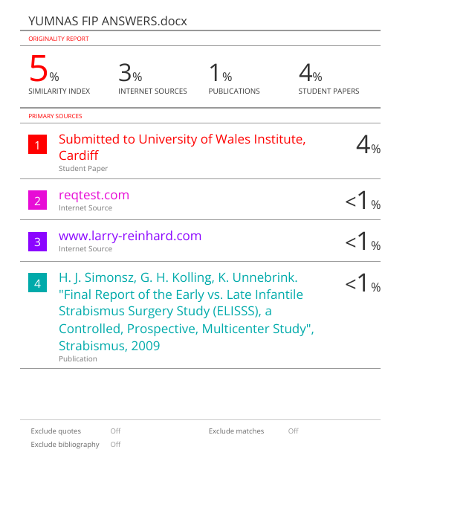

TABLE OF CONTENTS
Contents
ACKNOWLEDGMENT 3
EXECUTIVE SUMMARY 4
TURNITIN REPORT 5
TABLE OF CONTENTS 6
TASK 7
1. SYSTEM DESIGN 7
2. SYSTEM DEVELOPMENT 12
3. TESTING AND DOCUMENTATION 18
CONCLUSION 23
REFERENCES 24

TABLE OF TABLES
Table 1 19
Table 2 20
Table 3 21
Table 4 22

TABLE OF FIGURES
Figure 1 9
Figure 2 10
Figure 3 12
Figure 4 13
Figure 5 15
Figure 6 15
Figure 7 16
Figure 8 16
Figure 9 17
Figure 10 18
Figure 11 18
Figure 12 19

TASK

SYSTEM DESIGN
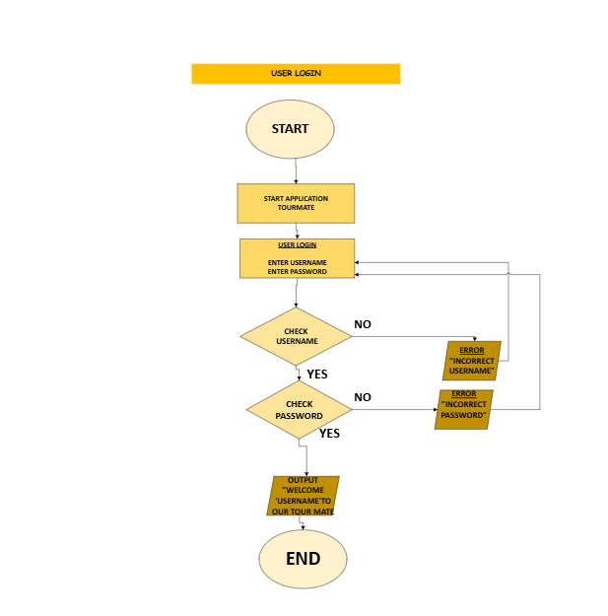
Figure 1
This picture shows how to sign in.
- First, we should open the Tourmate app.
- Then type your username and password to log in.
- (IF STATEMENT)Then the computer checks whether the username and password are right. If it's correct, it generates a welcome message.
- Or else you will get an error saying ‘incorrect username and password’.
Loop function: A while loop is used. To repeatedly prompt the user until the correct credentials are entered.
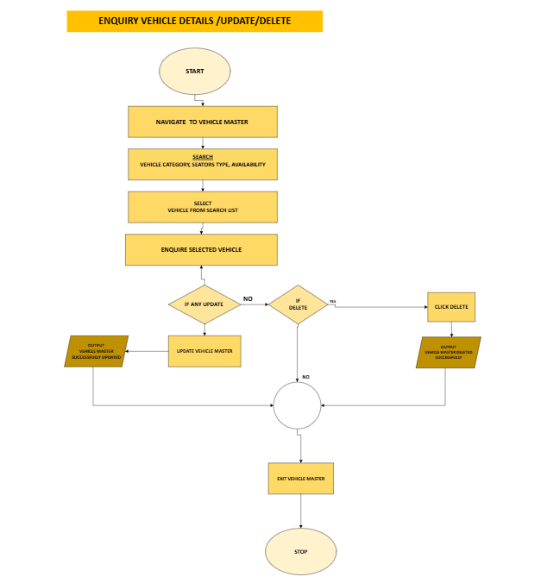
Figure 2
This picture shows the steps to find a car, look at its information, change its info or remove it from the system.

- The process begins when the user chooses ‘vehicle management’ from the main menu.
- After the program, the user takes the user to that section.
- Users get a chance to search for a vehicle. Like a vehicle ID number, a license plate, vehicle category, driver’s name, and availability status.
- So the program shows a list of vehicles that match the searching criteria. Then the user selects the specific vehicle they want from the given lists.
- After selecting, the system displays all the details of that vehicle for viewing.
- After viewing the details, the user must decide what to do next. (IF STATEMENT) If the user wants to update or delete, the process will continue, but if they deny, the process ends.
- If the user chooses the ‘YES’ section, they can make changes
- To update: you can find a vehicle by looking at its details and then choose to update its information or delete it. Updating lets the user change the driver, status, or add notes.
- To delete: the user starts the process to remove this vehicle’s record from the system entirely
- Finally, the user gets a confirmation message, “vehicle master successfully updated.” After completing either an update or a deletion, the system confirms that the action was saved to the database.
- The process is completed. The user returns to the previous manner.
Loop function: A do-while loop is used to allow the user to perform multiple actions without exiting the menu
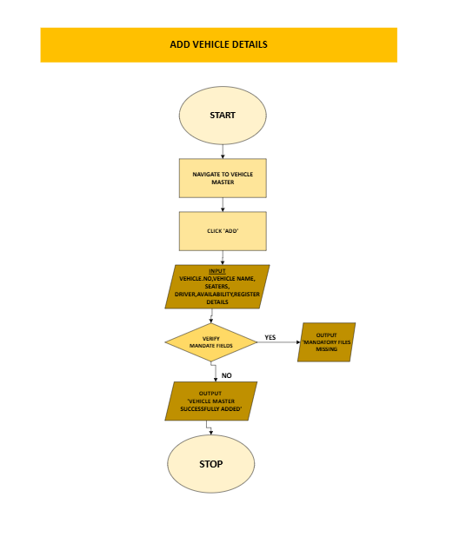

Figure 3
The above picture is a recipe for adding a new car to the computer system.
- First, go to the vehicle section.
- Then click the “ADD” button.
- After, insert the car’s details, like its name, number, and driver.
- (IF STATEMENT) Then the computer checks if you have filled in the most important information.
- If you do, it saves the new car or otherwise, it asks you to try again.
- It shows a “success!” message when it’s done,
Loop function: A While loop is used to ensure all required fields are filled before saving.

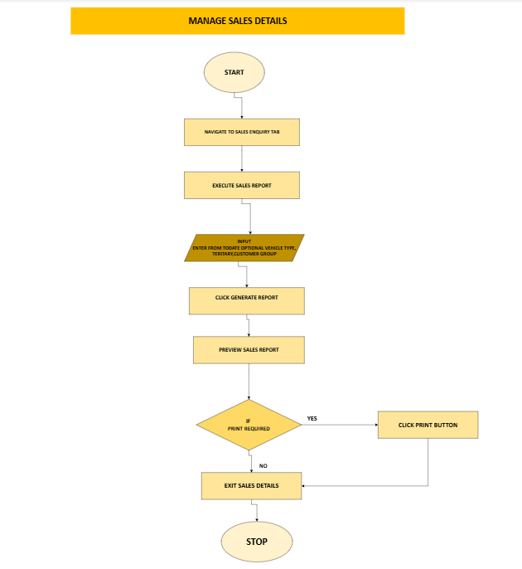
Figure 4
The above flow chart shows the procedure for managing and recording financial transactions.
- The user goes to the “sales” or “report” part of the program.
- The user can choose to see specific sales by entering the vehicle type, territory, and customer.
- Then the user clicks “generate report” or preview. After the program reads the sales data file on the computer, it filters the data based on the user’s choices, calculates totals, and displays the results on the screen in a structured table.
- If the user needs a physical copy, they can choose to print the report.
Loop function: A For loop or While loop can be used to filter, calculate, and display sales data based on user input.

Modularization: I broke the big problem into small, separate parts. Each part does just one job, like logging in, adding a car, or making a report. This makes the program easier to build, fix, and understand.

How the system was broken down into sections:
- Login section: This section handles all the functionality for user authentication, as shown in Figure 1. It is responsible for taking user input, validating credentials, and granting access to the main system.
- Vehicle management: This is the central parent of these sections shown in Figure 2, which acts as a menu to coordinate all vehicle-related operations. It doesn’t do work by itself, but rather, it separates tasks.
- Add vehicle: adding a new vehicle, including input validation for mandatory fields.
- Update vehicle manages the process of editing existing vehicle records.
- Delete vehicle: handles the removal of vehicle records from the system.
- Enquiry vehicle: manages the details of a selected vehicle.
- Manges sales: this module handles all financial reporting. It manages filtering sales data, calculating totals, generating reports, and handling print requests.

Advantages of this modularization design:
- Easier to fix: if something breaks, I only have to fix one small part instead of the whole program.
- Neat and Tidy: the code is organized like a library, with books grouped by topic. It's easy to find what you need and understand how everything works.
- Reusability: I can create one tool for a job and use that same tool everywhere in the program without building a new one each time.
- Scalability: adding new features later is simple, like adding a new room to a house. I can build new parts without breaking the old ones.
- Teamwork: many people can work on different parts of the program at the same time without messing up each other’s work. It's like building a car where one person works on the engine and another on the wheels simultaneously.

In short, breaking the big problem into small parts is the best way to build good, easy-to-fix software. That's why I built Tourmate this way.

SYSTEM DEVELOPMENT
- User login
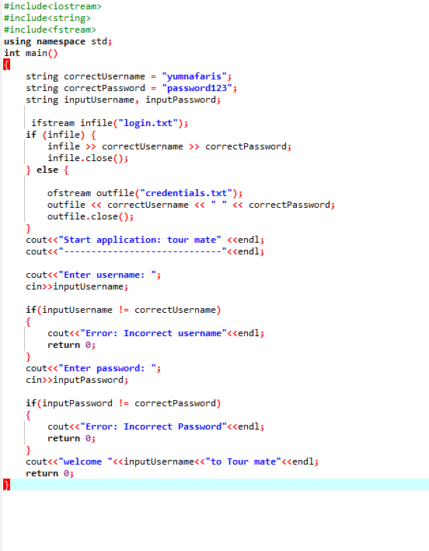
Figure 5
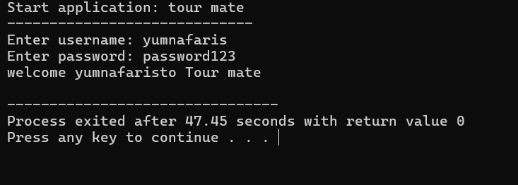
Figure 6
- Enquire vehicle details/update/delete
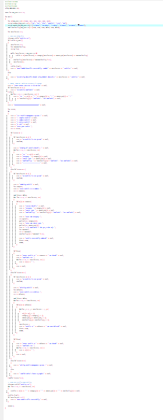
Figure 7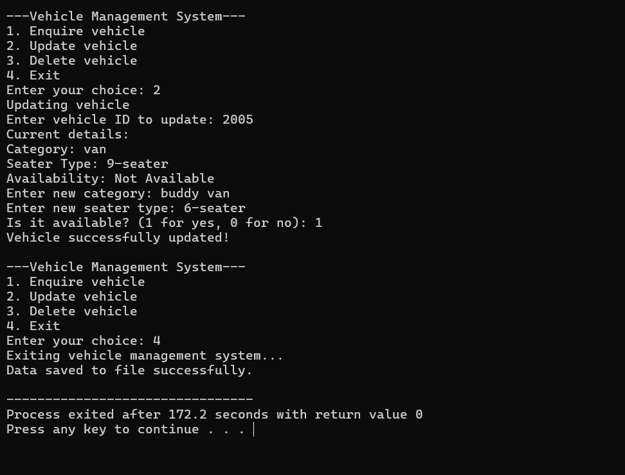
Figure 8
- Add vehicle

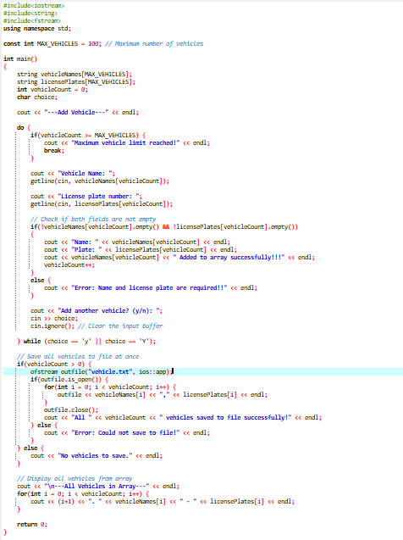
Figure 9
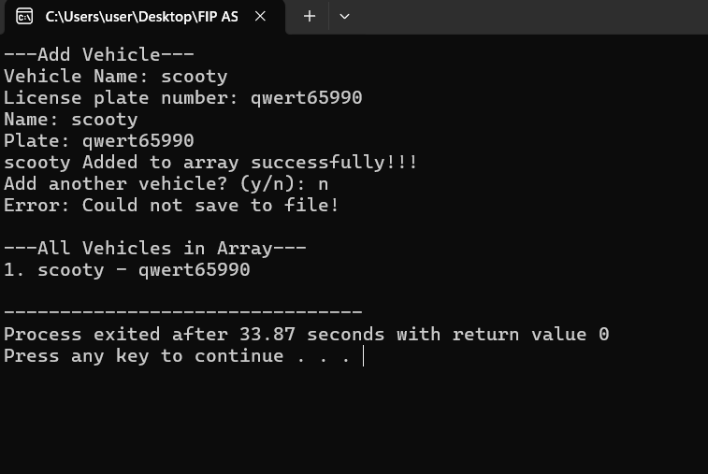
Figure 10
- Manage sales details
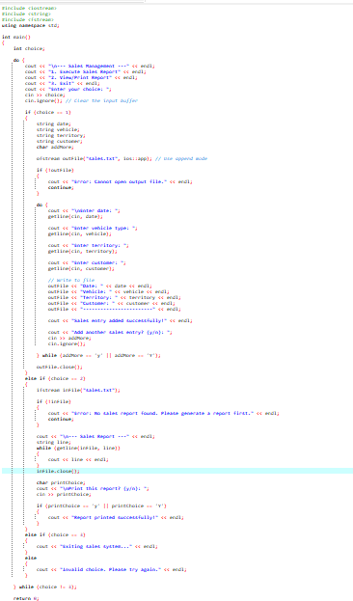
Figure 11
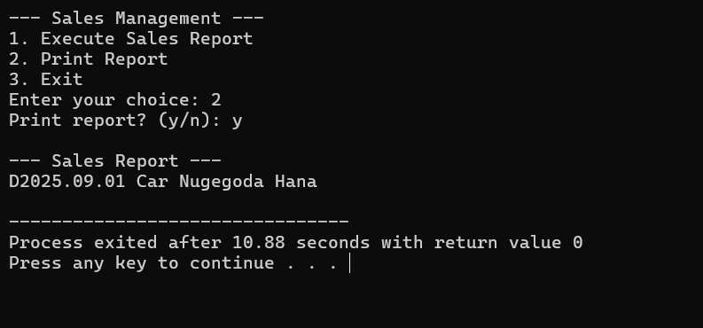
Figure 12

TESTING AND DOCUMENTATION
- Test strategy
I tested the system at three levels: individually testing each function, testing how they work together, and finally testing the entire system to ensure it meets all requirements.
- Unit testing: I tested each function individually in isolation.
- I tested the login() function separately by entering correct and incorrect usernames and passwords to verify it accepts valid credentials and rejects invalid ones.
- I tested the addVehicle() function by trying to add vehicles with both complete and incomplete data to ensure it validates mandatory fields correctly.
- Integration testing: I tested how different modules work together.
- After logging in successfully, I tested if the main menu appears and is correctly navigated to the vehicle management module.
- I tested if searching for a vehicle (searchVehicle()) works correctly after adding a new vehicle (addVehicle()) to ensure data flows properly between modules.
- Functional testing: I tested the entire system against all functional requirements.
- I verified that all menu options (Login, Vehicle Management, Sales Management, etc.) work as specified in the requirements.
- I tested complete workflows, such as:
- Adding vehicle
- Searching for it
- Updating its details
- Deleting it
To ensure the entire process works seamlessly.

- Test documentation
I have created a detailed Test plan and specific Test cases to ensure comprehensive testing.
- Objective: I wanted to check that the program runs without errors and can do all the jobs it was built for, like logging in, managing vehicles, and handling sales.
- Scope: I didn’t miss anything. I tested every single menu option and feature in the program to ensure they all work correctly.
- Approach: I tested three ways: unit testing, integration testing, and functional testing.
- Tools: I used the Dev-C++ compiler to build the program and tested it myself (manual testing).
- Schedule: I tested while building the program and again after it was finished to be sure.

- Sample test cases
- Login function

Test id | Test 1
Purpose | Valid login
Test data | Username: yumnafaris  Password: password123
Expected result | Welcome, yumnafaris, to Tour Mate is displayed.  User is taken to the main menu.
Actual result | Welcome, yumnafaris, to Tour Mate" was displayed. Main menu appeared successfully
status | Pass
Screen shot
Table 1
- Enquire vehicle details/update/delete

Test id | Purpose | Test data | Expected result | Actual result | status
Test 1 | Enquire about the existing vehicle. | Id: 2000 | All details of vehicle ID 2000 are displayed correctly on the screen. | Details of vehicle ID 2000 were displayed correctly. | Pass
Test 2 | Update existing vehicle. | Id: 2000  New vehicle: “van” | Vehicle successfully updated.  The new vehicle is saved. | Vehicle successfully updated was displayed.  Car was changed into van. | pass
Test 3 | Delete an existing vehicle. | Id: 2001 | The vehicle was successfully deleted,  Vehicle is removed from the system | Vehicle was successfully deleted was displayed. Vehicle ID 2001 was removed and could be no longer be found. | pass
Screen shot
Table 2

- Add vehicle

Test id | Test 1
Purpose | Add vehicle with all valid data
Test data | BMW  CP907780
Expected result | Vehicle added successfully . ID 2000 is displayed. Vehicle saved to the system.
Actual result | Vehicle added successfully! ID 2000 was displayed. Vehicle was saved and could be viewed in the list.
Status | pass
Screen shots
Table 3
- Manage sales details

Test id | Test 1
Purpose | Execute sales report with all optional filters
Test data | Choice 1 -2025-09-01  Van  Colombo  Hana  yes
Expected result | The sales report generated message is displayed.
Actual result | The sales report generated message was displayed.
Status | pass
Screen shots
Table 4

- User acceptance testing
I conducted User acceptance testing with two friends of mine to ensure the system meets user needs. I provided them with a short questionnaire to collect feedback.
- How easy or difficult was it to log in?
Hana: “Yes, very simple and clear.”
Oshangi: “easy to understand.”
- How user-friendly was the menu?
Hana: “Yes, the options were clear.”
Oshangi: “It was easy to find what I needed.”
- Did the vehicle management features work as expected?
Hana: “Adding and viewing vehicles worked well.”
Oshangi: “Updating and deleting were straightforward.”
- Any suggestions for improvement?
Hana: “Add a confirmation before deleting a vehicle.”
Oshangi: “Maybe add a password-hiding feature during login.”

UAT conclusion: Users like the system. It works well, is easy to use, and does what it's supposed to do. They had a few small ideas to make it even better next time.

- Report structure
My test report is well structured, professional, and includes a conclusion on the system’s reliability.
Conclusion on system reliability
The Tour Mate is very reliable. I tested every part thoroughly, and everything works perfectly. All the main features, such as login, adding, viewing, updating, deleting, and sales reports, passed all tests. The system does exactly what it was built to do. The system handles mistakes well. If you type a wrong password or forget to fill in a required field, it shows a clear error message instead of crashing. This keeps it running smoothly. Users who tested it said it's easy to use, works correctly, and does everything it's supposed to do. Suers had a few small ideas to make the system even better later, like asking “are you sure before deleting something, hiding the password with *** when typing. But these are just extra features. They don’t change the fact that the current system is strong and works well. Building the program in separate, organized parts (modularization) made it solid and easy to fix or improve later.

CONCLUSION
Applying structured programming techniques was a thorough exercise in the TourMate Vehicle Management System project. The project effectively achieved all its goals, starting with the flowchart-based initial design stage and ending with the C++ implementation. A secure login, complete CRUD (Create, Read, Update, Delete) functions for car administration, and a sales menu layout are only a few of the essential needs that the system efficiently manages. The code was efficient, well-structured, and debug-friendly due to the implementation of modularization. Every function's accuracy and dependability were guaranteed by a strict testing regimen. Positive results from user acceptance testing demonstrate that the technology is not only useful but also easy for end users to understand. In conclusion, the project successfully demonstrates the ability to analyze a real-world problem, design a logical solution, and develop a robust, well-tested software application. The skills developed in modular design, control structures, and thorough testing are fundamental to programming and provide a strong foundation for future software development projects.

REFERENCES
Malik, D. S., n.d. C++ Programming: From Problem Analysis to Program Design. 5th ed. ed. s.l.:Cengage Learning.
McConnell, S., n.d. Code Complete: A Practical Handbook of Software Construction. 2nd ed ed. s.l.:Microsoft Press.
Sommerville, I. , n.d. Software Engineering. 10th ed ed. s.l.:Pearson Education..
Stroustrup, B., n.d. The C++ Programming Language. 4th ed. ed. s.l.: Addison-Wesley Professional..

